VistA Imaging Application Download Management

# URL

<http://vhacvixclu1a.r04.med.va.gov/Distrib/>

# Security

## Authentication

Users are authenticated using Windows Authentication (Kerberos). Windows will automatically authenticate the user using the username the person used to log on to the VA network. This works for any domain in the VA Active Directory forest.

If the user did not log in to the workstation using a domain account, the user will be prompted for domain credentials. The username must be in the form: domain\username. For example: vhamaster\vhaiswxxxx.

## Roles

The application has three roles:

* User  
  Can download files and view personal download history
* Report Viewer  
  Has all of the permissions of a user role and can view the report of the download history
* Admin  
  Has all of the permissions of a user and report viewer roles and can manage user roles and setup downloads.

## Managing Roles

To manage users, select Admin\Users from the menu. You will be able to edit existing user’s roles and add new users. The username must be the user’s domain account in the form domain\username. User’s not listed will automatically be granted access to only the download section of the site. Only site Admins and Report Viewers must be specified here.

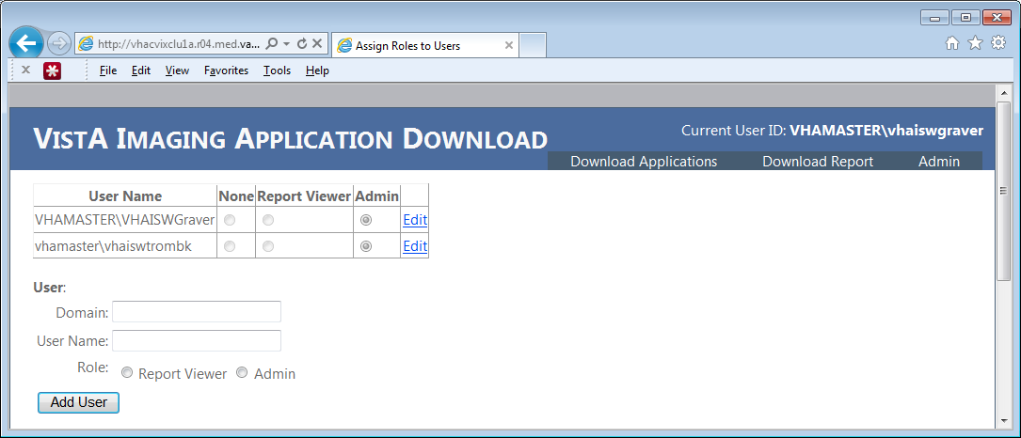

# Managing downloads

## Uploading Files

Files may be placed on the file share:  
\\vhacvixclu1a.r04.med.va.gov\Distrib$

## Adding the download link

1. Select Admin/Applications from the menu  
   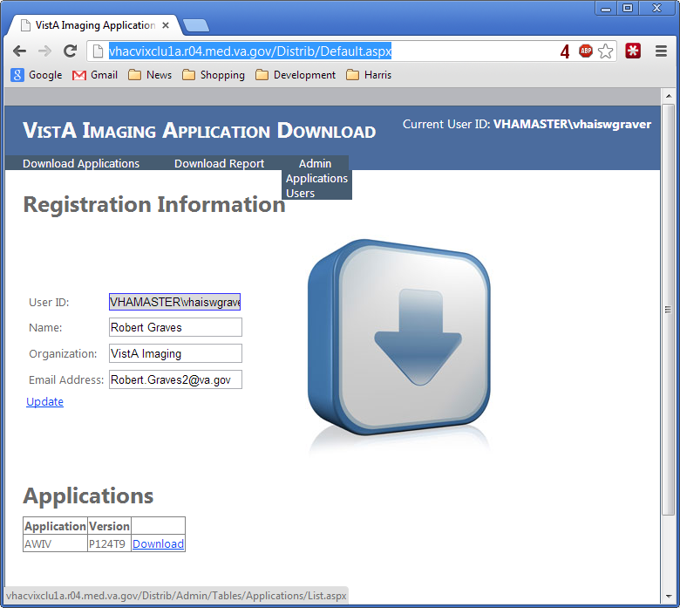
2. Click the Insert new item link at the bottom of the page  
   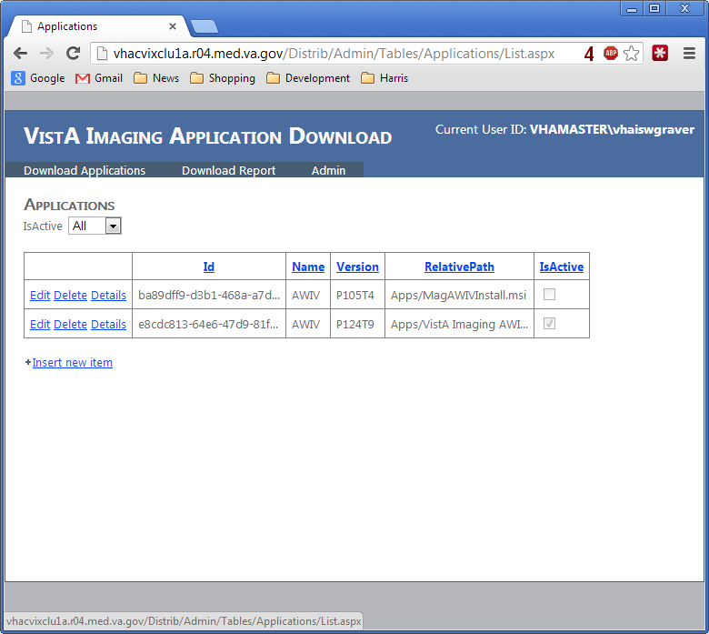
3. Enter the details of the new file. The Relative Path is Apps/Filename.  
   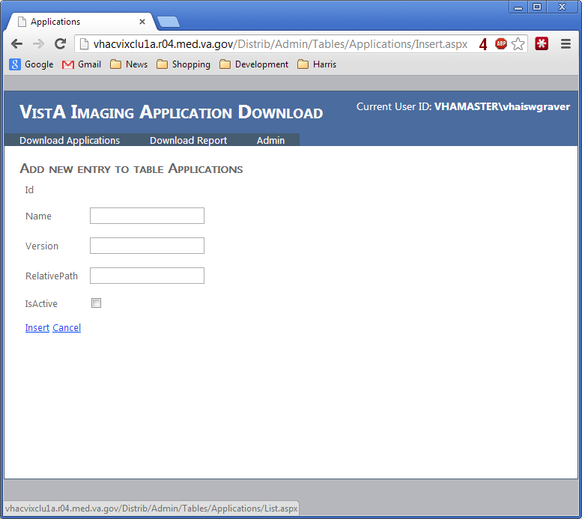
4. Click the Insert link at the bottom of the page.

Note: Users will only see the application if the IsActive checkbox is checked.

## Editing the download link

1. Select Admin/Applications from the menu
2. Click the edit link on the item you wish to edit.
3. Make your changes.
4. Click the Update button

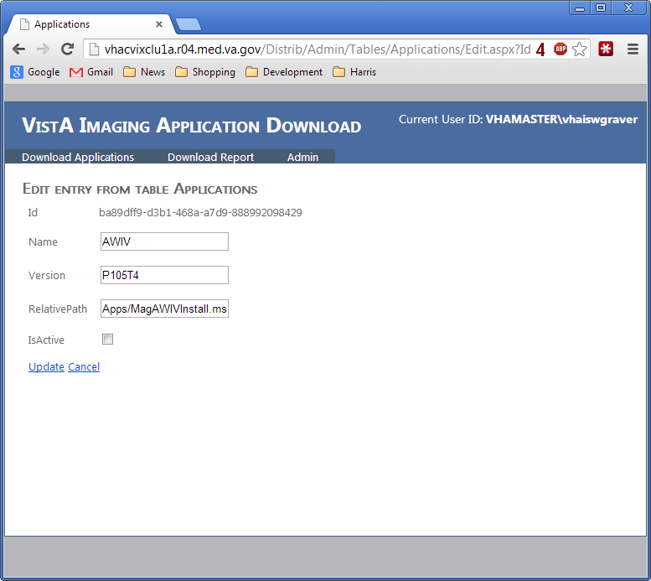

# Download Report

The site tracks which users download which applications and which version of the application. Users with a role of Admin or Report Viewer can access the download report from the menu. The report may be filtered to the information of interest. The report may be downloaded in Comma Separated Value (CSV) format by the download button on the bottom of the page. 